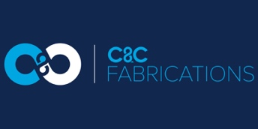

JOB DESCRIPTION

JOB TITLE: Welder

REPORTS TO: Workshop Foreman

JOB PURPOSE: Assembly of manufactured components

RESPONSIBILITIES

- Manufacture items to a given drawing, using jigs and fixtures where applicable, to an agreed standard, ensuring that the finished product conforms fully to the original drawing in dimensions and quality.

- Ensure your working section is organised and tidy.

- Strictly adhere to C & C Fabrications working procedures maintaining a tidy and professional appearance and making full use of the PPE provided.

HEALTH & SAFETY

The responsibility for employees’ health and safety does not rest entirely with the Company and its management. As an employee, irrespective of your position in the Company, you have a legal duty of care to adhere to the company policy at all times. You must maintain a safe and healthy working environment, take care of your own health, safety and environment at work and of other colleagues who may be affected by your actions or omissions.

GENERAL RESPONSIBILITIES

This job description covers the main objectives, responsibilities and authorities of this position at present. Where necessary, changes may be made from time to time involving like or integrated work.

Name: __________________________

Signed (Employee) __________________________ Date: ______________

Name __________________________

Signed (Manager) __________________________ Date: ______________

